

The Oklahoma Pipeline Energy Storage System (OPESS)

By Jonathan Grinnell

Fall 2022



en.645.800

Mentor Robert Krzystan

|  |  |
| --- | --- |
| Document Name | Reason for Change |
| Grinnell_Proposal | Initial Document |
| Grinnell_Proposal_A | Updated with initial set of professor comments. |
| Grinnell_Proposal_B | Updated with secondary set of professor comments. |

Table of Contents

1 Project Introduction 5

1.1 System Description 5

1.2 Student Biography 5

2 Need for the System 5

2.1 System Need 5

2.2 System Concept 7

3 System Architecture/Description of System 7

3.1 System Context Diagram 7

3.2 System Conceptual Block Diagram 8

4.1 Stakeholders 10

4.2 WBS 11

4.3 Milestones 13

4.4 Schedule 14

4.5 Earned Value Management (EVM) 14

4.6 Risk Management 20

4.6.1 Risk 1:Weather 20

4.6.2 Risk 2:Earthquakes 20

4.6.3 Risk 3:Residual Natural Gas 21

4.6.4 Risk 4:Cyber Security 21

5 Systems Engineering Justification 22

5.1 Why systems Engineering 22

5.2 Three operational scenarios 22

5.3 Measures of Effectiveness 23

5.4 Measures of Performance 23

5.5 Tools and Techniques 24

6 References 25

**Table of Figures**

Figure 1: Make up of Oklahoma power generation by year from 2001 to 2019 6

Figure 2: System Context Diagram 8

Figure 3: System Conceptual Block Diagram 10

Figure 4: Schedule 14

Figure 5: CPI/SPI Graph 19

Figure 6: Risk 1 Worksheet 20

Figure 7: Risk 2 Worksheet 20

Figure 8: Risk 3 Worksheet 21

Figure 9: Risk 4 Worksheet 21

**Table of Tables**

Table 1: List of Solution Needs 6

Table 2: WBS 11

Table 3: Milestones 13

Table 4: EVM 14

Table 5: Scenario Summary 23

Table 6: MOE Summary 23

Table 7: MOP Summary 24

1 Project Introduction

## 1.1 System Description

The **Oklahoma Pipeline Energy Storage System (OPESS)** is a system of used natural gas wells, compressors, generators and control centers that are capable to storing compressed air deep underground. Many plain states have dedicated considerable time and energy into developing wind energy resources but lack any way of storing excess energy it produces. This has led to a continued dependance on fossil fuels in the area. The OPESS aim to provide an energy storage solution capable of storing excess power generated on windy days for use when those capabilities are offline.

## 1.2 Student Biography

Jonathan Grinnell moved around Texas a lot growing up but eventually wound up in Houston. He graduated from the University of Oklahoma in 2014 where he got a Batchelor’s in Physics. After a brief stent at Boeing, he landed a career at Northrup Grumman where he has focused on software test electronic warfare. In his spare time, he and his wife enjoy working on cosplays and home brewing. He has a cat who thinks he runs the place.

2 Need for the System

## 2.1 System Need

Oklahoma, since the turn of the century, has spent a considerable amount of time and energy into building and expanding its energy portfolio. These changes have happened in a way that largely mirrors the global energy market with coal shrinking in scope and natural gas taking over as a primary supplier of the state’s energy needs. Unexpectedly however, wind has emerged as another major supplier to the states market. In 2010, Oklahoma mandated that 15% of energy generation needed to be from some kind of renewable resources by 2015. By 2012, the state had exceeded that goal primarily through the installation of wind farms though solar does make an appearance on a small scale. By 2019 wind comprised 35% of the power generated in Oklahoma (Popovich & Plumer, 2020). By 2021 that number had gone up to 41% with another 4% coming from other renewable sources (U.S. Energy Information Administration, 2022).

Figure 1: Make up of Oklahoma power generation by year from 2001 to 2019

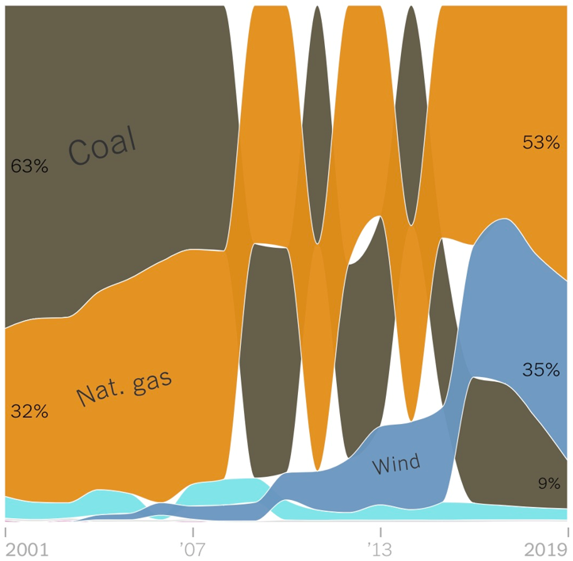

(Popovich & Plumer, 2020).

The increase in renewable energy comes with a decrease in reliability. The sun doesn’t always shine and the wind doesn’t always blow. Worse yet, Oklahoma has a windy season when energy production is at its peak. This means that during that time, an excess of energy may be produced and waisted rather than stored for later in the year during less windy times. Batteries do provide a solution but have their limitations.

The Rush Springs Storage facility was installed near Marlow Oklahoma in 2020 with a capacity of 10 megawatt for 2 hours (NextEra Energy, 2020). That is a very significant amount of power but it would not be able to maintain that level of power for days to weeks if the weather changed in an unfavorable way. A new solution is needed that is able to take excess energy produced in windy months and store it for a long period of time. The current solution relies on continued presence of natural gas on the grid to pick up the slack. To achieve a green energy solution, grid level storage must be readily available. Oklahoma Pipeline Energy Storage System (OPESS) aims to meet this need.

Table 1: List of Solution Needs

|  |  |  |
| --- | --- | --- |
| Number | Name | Description |
| 1 | Extra Storage | The OPESS needs to be able to store extra energy from renewable sources during times of over production. |
| 2 | Low-Cost Storage | The OPESS needs to be able to store energy produced on the grid during low rates for use during times of high rates |
| 3 | Long Term Storage | The OPESS needs to be able to store energy for a significant amount of time with minimal loss. This will be measured on the timeframe of months to years. |
| 4 | Grid Scale Storage | The OPESS needs to be able to provide an energy storage solution that can be maintained on a grid level. |

## 2.2 System Concept

The OPESS will be composed of 2 major sub systems, the Energy Storage Subsystem (ESS) subsystem and the Command-and-Control Subsystem (CaCS). The two subsystems will communicate over a secured internet connection. This will enable a single controller subsystem to communicate with an control multiple instances of GAS, allowing them to be places around the state and act as a modular form of energy storage.

The ESS will be fairly hardware focused as most of the design will revolve around storing compressed air and generating power off it. The CaCS will act as the brains of the OPESS. While HW will be present in the system, the CaCS will mostly be composed of software components that will allow for communication between the ESS, other utility companies as well as staff internal to the CaCS. Additionally, the ESS will need to be able to quickly respond in an autonomous way to the commands given it by the CaCS.

The ESS will be a series of spent natural gas wells leased to the company via the petroleum industry. Air will be forced down the pipeline and allowed to build pressure. This pressure will be allowed to go pretty high but will be kept under the natural pressure the pipeline was at while still under use for safety reasons. Energy will in this way be stored deep underground in the form of compressed air. When energy needs to be taken from storage, the pumps will shut off and allow the air to be released. The released air will turn a turbine and generate electricity. The amount of air being released will be allowed to vary as to allow for more control over the amount of power generated.

The CaCS will be in contact with power plants and grid operators across the state. This will allow them to better predict and control when and how the ESS subsystem will store or generate power. The controller subsystem will be able to communicate with and control multiple instances of ESS so that total power output can exceed that of a single instance if the need calls for it. This will also allow for the system to generate for a longer period of time as the total amount of storage available to the controller is only limited to the number of instances of the ESS available.

As wind power tops 40% of Oklahoma’s energy generation and total renewable generation is climbing to be just shy of 50%; energy storage solution will become increasingly important to insure a stable and functional grid. Compressed air storage systems like OPESS, provide benefits to utility companies like selling energy produced during off peak hour during peak hours for added profitability. They are also easily scalable, providing effective grid level storage across the state (Quincy Compressor, 2020).

3 System Architecture/Description of System

## 3.1 System Context Diagram

On a high level, the OPESS really exists to fulfill two functions; store energy and create energy. To do that the OPESS system will need to be connected to the local power grid. Whenever excess power is generated or even when rates are low, the OPESS pumps can run in an effort to store energy for a later time period. When demand exceeds supply or when rates might be high, the OPESS can use that stored energy and put it back on the grid.

In order to know what’s happening with the rates or what the current demand is, an utility worker will remain on scene to provide knowable and depth of experience into the running of the OPESS system. In order to facilitate this function, the OPESS will also be connected to the internet so as to help with real time communication.

As far as physical hardware goes, the OPESS will be also be exposed to the external environment around it. Due to the nature of the system, this environment has been broken up into both a meteorological environment as well as a geological environment. On the outside, the OPESS system will be exposed to high wings, rain, hail and the occasional tornado. From a geological perspective, the OPESS will also be exposed to high pressure, rocks and geological formations as well as the occasional earthquake. See Figure 2: System Context Diagram.

Figure 2: System Context Diagram

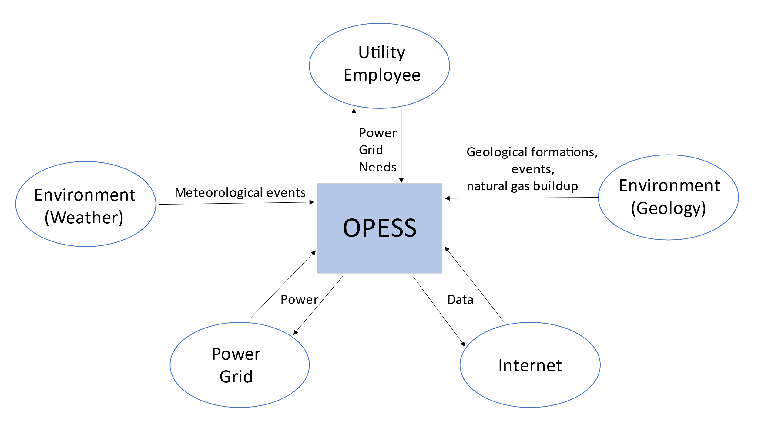

## 3.2 System Conceptual Block Diagram

The OPESS can be broken down into two smaller subsystems, the Energy Storage Subsystem (ESS) and the Command-and-Control Subsystem (CaCS). See Figure 3: System Conceptual Block Diagram.

The ESS consists of the compressed air storage as well as the physical storage, generators and any pipes or pluming needed to move the stored compressed air to the generators. The ESS is also the component that will be most exposed to the outside environment. As mentioned in the Context diagram, the outside environment can be broken down into two different regions, the weather or meteorological region and the geology region. As Oklahoma is famous for its weather, the ESS will need to be able to handle extremes such as high winds, rain, hail and tornadoes. The ESS has a small foot print when compared to the area of the state, but tornadoes are a yearly risk that the ESS will need to be able to address.

Since the ESS also has an underground component, it will also have to interact with the geology of a given reason. Since the ESS will be storing compressed air underground, it will have to interact with the local geology including, soil and rock layers, limestone inclusions and salt domes. Additionally, Oklahoma has been experiencing an increase in earthquakes in recent years. The ESS will need to be able to handle a small to moderate earthquake and continue to function.

In addition to the environment, the ESS will also need to be able to integrate with the local electric grid. This involves both pulling power off the grid in an effort to store extra energy produced by an over production of wind as well as energy produced during times of the day or even year when the rates are low. It will also need to be able to run generators so that it can provide power back onto the grid. This will be done at times when local wind farms are under producing expectations or when the rates that day are particularly high.

The CaCS acts as the brain of the OPESS. Utility workers will be able to control the ESS from this location as well as communicate with other utility operational centers and power plants. In this way, the OPESS will be able to see the need vs production of a particular region and order the ESS to either store or generate energy in just such a way as to meet current demand.

The CaCS will, like the ESS, needs to be connected to the local power grid. Unlike the ESS however, this is only a one-way path as the CaCS will require grid power in order to operate.

What links the CaCS and the ESS together is the internet. Once the needs of the grid are determined by the CaCS the decision will be sent via the internet to the ESS. The ESS will receive this data and execute accordingly. Maintenance data, current system statistics current power generation and usage will be sent back to the CaCS for further processing. See figure 3 for the full breakdown.

Figure 3: System Conceptual Block Diagram

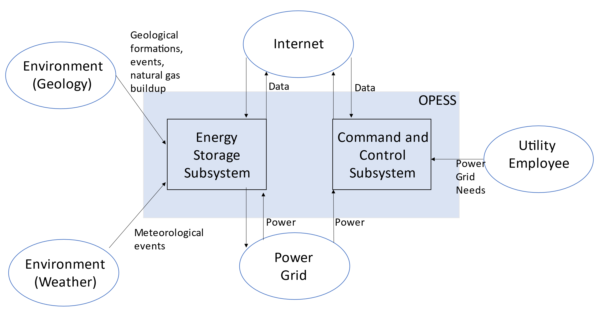  
4 Project Background

## 4.1 Stakeholders

In an effort to better understand the technical needs of the OPESS, several stakeholders will be contacted and interviewed over the course of this project. These stakeholders will represent experts in their field and will play a critical role in understanding how the OPESS will interact with environment. Three critical points of interest have been identified.

Local Electrical Utility Economist: In an effort to understand how power is purchased between different plants, localities and states, an economist with a utility company will need to be consulted. This will better allow engineering to understand how power is distributed across the power grid and how an energy storage solution and impact other power producers even though they might not be owned or operated by a related utility.

Petroleum Engineer: Since energy will be stored underground in natural gas wells, an expert on those wells will need to be consulted. Information will have to be acquired about local geology, seismic activity, residual natural gas still in the well as well as a high-level understanding of how the natural gas wells themselves are designed.

Cyber Security Expert: The ESS and the CaCS both communicate with each other over the internet so as to maintain a central command structure for multiple instances of ESS. This leaves the OPESS open to cyber-attack. Given the power grid has been labeled critical infrastructure (NIST, 2018), having a network developed that would be resilient to cyber-attacks would be important. Not just for the OPESS but for the over all grid it is connected too.

4.2 WBS

The work breakdown structure (WBS), listed below, provides a high-level overview of the tasks that are expected to be done under the OPESS project. The project is expected to start May 9th of 2022 and run until December 16 of 2022. 268.5 hours of effort are estimated to be needed to complete this project. For a more detailed tracking of the labor required, please see the EVM section of this document.

Table 2: WBS

| WBS number | Name | | | Duration | Start | Finish | Hours |
| --- | --- | --- | --- | --- | --- | --- | --- |
| 1 | Project Concept | | | 0 days | 5/9/2022 | 5/9/2022 | 0.5 |
| **2** | **Project Proposal** | | | **45 days** | **5/9/2022** | **7/8/2022** |  |
| 2.1 | System Introduction | | | 5 days | 5/9/2022 | 5/13/2022 | 10 |
| 2.2 | System Need | | | 5 days | 5/16/2022 | 5/20/2022 | 5 |
| 2.3 | WBS | | | 5 days | 5/23/2022 | 5/27/2022 | 5 |
| 2.4 | Schedule | | | 5 days | 5/30/2022 | 6/3/2022 | 1 |
| 2.5 | Risk Assessment | | | 5 days | 6/6/2022 | 6/10/2022 | 3 |
| 2.6 | Systems Engineering Justification | | | 5 days | 6/13/2022 | 6/17/2022 | 5 |
| 2.7 | Professor Feedback | | | 14 days | 6/20/2022 | 7/7/2022 | 10 |
| 2.8 | Acceptance | | | 1 day | 7/8/2022 | 7/8/2022 | 1 |
| **3** | **Requirements Report** | | | **23 days** | **7/8/2022** | **8/9/2022** |  |
| 3.1 | Research Technical information | | | 3 days | 7/8/2022 | 7/12/2022 | 6 |
| 3.2 | Schedule Interviews | | | 3 days | 7/8/2022 | 7/12/2022 | 3 |
| 3.3 | Perform Interviews | | | 3 days | 7/13/2022 | 7/15/2022 | 3 |
| 3.4 | Create Appendix of Interviews and Site Sources | | | 1 day | 7/18/2022 | 7/18/2022 | 3 |
| 3.5 | Develop ConOps | | | 7 days | 7/18/2022 | 7/26/2022 | 5 |
| 3.6 | Develop Key Performance Parameters | | | 2 days | 7/18/2022 | 7/19/2022 | 3 |
| 3.7 | Begin VCRM | | | 3 days | 7/27/2022 | 7/29/2022 | 2 |
| 3.8 | Turn in Requirements Report | | | 0 days | 7/29/2022 | 7/29/2022 | 0.5 |
| 3.9 | Rework Requirements Report | | | 7 days | 8/1/2022 | 8/9/2022 | 10 |
| **4** | **Functional Analysis** | | | **24 days** | **8/1/2022** | **9/1/2022** |  |
| 4.1 | Develop Functions | | | 7 days | 8/1/2022 | 8/9/2022 | 10 |
| 4.2 | Develop Function Connectivity | | | 3 days | 8/10/2022 | 8/12/2022 | 5 |
| 4.3 | Develop Function Decomposition | | | 3 days | 8/15/2022 | 8/17/2022 | 5 |
| 4.4 | Update CORE | | | 3 days | 8/18/2022 | 8/22/2022 | 3 |
| 4.5 | Turn in Functional Analysis | | | 0 days | 8/23/2022 | 8/23/2022 | 0.5 |
| 4.6 | Rework Functional Analysis | | | 7 days | 8/24/2022 | 9/1/2022 | 10 |
| **5** | **Concept of Operations** | | | **28 days** | **8/24/2022** | **9/30/2022** |  |
| 5.1 | Break ConOps down 3 levels | | | 7 days | 8/24/2022 | 9/1/2022 | 10 |
| 5.2 | Develop Physical Block Diagrams | | | 7 days | 9/2/2022 | 9/12/2022 | 5 |
| 5.3 | Develop Physical-Functional Traceability | | | 3 days | 9/13/2022 | 9/15/2022 | 5 |
| 5.4 | Update CORE | | | 3 days | 9/16/2022 | 9/20/2022 | 2 |
| 5.5 | Turn in Concept of Operations | | | 0 days | 9/21/2022 | 9/21/2022 | 0.5 |
| 5.6 | Rework Concept of Operations | | | 7 days | 9/22/2022 | 9/30/2022 | 10 |
| **6** | **Trade Study** | | | **19 days** | **9/22/2022** | **10/18/2022** |  |
| 6.1 | Decide on Trade Study Topic | | | 7 days | 9/22/2022 | 9/30/2022 | 10 |
| 6.2 | Perform Trade Study | | | 3 days | 10/3/2022 | 10/5/2022 | 3 |
| 6.3 | Perform Sensitivity Analysis | | | 1 day | 10/6/2022 | 10/6/2022 | 1 |
| 6.4 | Turn in Trade Study | | | 0 days | 10/7/2022 | 10/7/2022 | 0.5 |
| 6.5 | Rework Trade Study | | | 7 days | 10/10/2022 | 10/18/2022 | 5 |
| **7** | **Risk Management Report** | | | **75 days** | **7/20/2022** | **11/1/2022** |  |
| 7.1 | Risk Assessment During Requirements Report | | | 1 day | 7/20/2022 | 7/20/2022 | 2 |
| 7.2 | Risk Assessment During Functional Analysis | | | 1 day | 8/23/2022 | 8/23/2022 | 2 |
| 7.3 | Risk Assessment During ConOps | | | 1 day | 9/21/2022 | 9/21/2022 | 2 |
| 7.4 | Risk Assessment During Trade Study | | | 1 day | 10/7/2022 | 10/7/2022 | 2 |
| 7.5 | Perform Final Risk Assessment | | | 3 days | 10/19/2022 | 10/21/2022 | 2 |
| 7.6 | Turn in Final Risk Assessment | | | 0 days | 10/21/2022 | 10/21/2022 | 0.5 |
| 7.7 | Rework Final Risk Assessment | | | 7 days | 10/24/2022 | 11/1/2022 | 5 |
| **8** | **Test Plan** | | | **25 days** | **10/19/2022** | **11/22/2022** |  |
| 8.1 | Complete VCRM | | | 5 days | 10/19/2022 | 10/25/2022 | 5 |
| 8.2 | Develop Tests | | | 5 days | 10/26/2022 | 11/1/2022 | 5 |
| 8.3 | Assign Requirements to Individual Tests | | | 5 days | 11/2/2022 | 11/8/2022 | 3 |
| 8.4 | Develop Test Environment | | | 3 days | 11/9/2022 | 11/11/2022 | 5 |
| 8.5 | Turn in Test Plan | | | 0 days | 11/11/2022 | 11/11/2022 | 0.5 |
| 8.6 | Rework Test Plan | | | 7 days | 11/14/2022 | 11/22/2022 | 10 |
| **9** | **System Specifications** | | | **103 days** | **7/20/2022** | **12/9/2022** |  |
| 9.1 | Develop Lessons Learned from Requirements Analysis | | | 1 day | 7/20/2022 | 7/20/2022 | 1 |
| 9.2 | Develop Lessons Learned from Functional Analysis | | | 1 day | 8/23/2022 | 8/23/2022 | 1 |
| 9.3 | Develop Lessons Learned from Physical Analysis | | | 1 day | 9/21/2022 | 9/21/2022 | 1 |
| 9.4 | Develop Lesions Learned from Trade Study | | | 1 day | 10/7/2022 | 10/7/2022 | 1 |
| 9.5 | Develop Verifiable Requirements (VCRM) | | | 5 days | 11/14/2022 | 11/18/2022 | 10 |
| 9.6 | Assign Measures of Performance to all Requirements | | | 5 days | 11/21/2022 | 11/25/2022 | 5 |
| 9.7 | Develop Quantitative Requirements Metric | | | 3 days | 11/28/2022 | 11/30/2022 | 3 |
| 9.8 | Turn in System Spec | | | 0 days | 11/30/2022 | 11/30/2022 | 0.5 |
| 9.9 | Rework System Spec | | | 7 days | 12/1/2022 | 12/9/2022 | 10 |
| **10** | **Final Report** | | | **115 days** | **7/11/2022** | **12/16/2022** |  |
| 10.1 | Proposal EVM | | | 1 day | 7/11/2022 | 7/11/2022 | 0.5 |
| 10.2 | Requirements Report EVM | | | 1 day | 8/10/2022 | 8/10/2022 | 0.5 |
| 10.3 | Functional Analysis EVM | | | 1 day | 9/2/2022 | 9/2/2022 | 0.5 |
| 10.4 | Concept of Operations EVM | | | 1 day | 10/3/2022 | 10/3/2022 | 0.5 |
| 10.5 | Trade Study EVM | | | 1 day | 10/19/2022 | 10/19/2022 | 0.5 |
| 10.6 | Risk Management EVM | | | 1 day | 11/2/2022 | 11/2/2022 | 0.5 |
| 10.7 | Test Plan EVM | | | 1 day | 11/23/2022 | 11/23/2022 | 0.5 |
| 10.8 | Systems Spec EVM | | | 1 day | 12/12/2022 | 12/12/2022 | 0.5 |
| 10.9 | Perform EVM analysis | | | 1 day | 12/13/2022 | 12/13/2022 | 3 |
| 10.10 | Identify Follow on Activities | | | 1 day | 12/14/2022 | 12/14/2022 | 3 |
| 10.11 | Compile Final Report | | | 1 day | 12/12/2022 | 12/12/2022 | 3 |
| 10.12 | Turn in Final Report | | | 0 days | 12/12/2022 | 12/12/2022 | 0.5 |
| **11** | **Oral Presentation** | | | **4 days** | **12/13/2022** | **12/16/2022** |  |
| 11.1 | Develop Slides | | | 3 days | 12/13/2022 | 12/15/2022 | 15 |
| 11.2 | Give Presentation | | | 1 day | 12/16/2022 | 12/16/2022 | 2 |
| Total Hours: | | 268.5 |

## 4.3 Milestones

Table 3: Milestones

| **Milestone** | **Date** |
| --- | --- |
| Project Proposal | 7/8/2022 |
| Requirements Report | 7/29/2022 |
| Functional Analysis | 8/23/2022 |
| Concept of Operations | 9/21/2022 |
| Trade Study | 10/7/2022 |
| Risk Management Report | 10/21/2022 |
| Test Plan | 11/11/2022 |
| System Specifications | 11/30/2022 |
| Final Report | 12/12/2022 |
| Oral Presentation | 12/16/2022 |

## 4.4 Schedule

Figure 4: Schedule

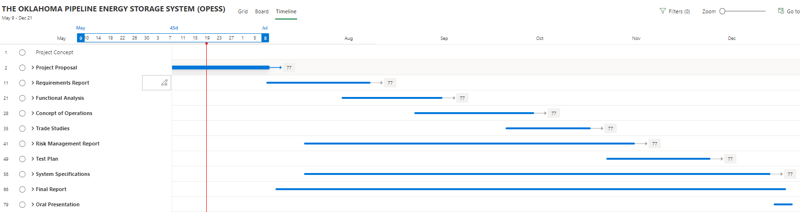

4.5 Earned Value Management (EVM)

The below table will be used to track the EVM of the program. Here, budget will be claimed and actuals tracked. Additionally, schedule and cost performance indexes will be tracked in an effort to help keep the project of schedule.

Table 4: EVM

| WBS number | Name | % Complete | Budget | BCWP | ACWP | SCI | CPI |
| --- | --- | --- | --- | --- | --- | --- | --- |
| 1 | Project Concept | 100.00% | 0.5 | 0.50 | 0.5 | 1 | 1 |
| **2** | **Project Proposal** | **79.13%** |  |  |  |  |  |
| 2.1 | System Introduction | 100.00% | 10 | 10.00 | 3 | 1 | 3.333333333 |
| 2.2 | System Need | 100.00% | 5 | 5.00 | 5 | 1 | 1 |
| 2.3 | WBS | 100.00% | 5 | 5.00 | 5 | 1 | 1 |
| 2.4 | Schedule | 100.00% | 1 | 1.00 | 1 | 1 | 1 |
| 2.5 | Risk Assessment | 100.00% | 3 | 3.00 | 1 | 1 | 3 |
| 2.6 | Systems Engineering Justification | 100.00% | 5 | 5.00 | 2 | 1 | 2.5 |
| 2.7 | Professor Feedback | 33.00% | 10 | 3.30 | 2 | 0.33 | 1.65 |
| 2.8 | Acceptance | 0.00% | 1 | 0.00 |  | 0 |  |
| **3** | **Requirements Report** | **0.00%** |  |  |  |  |  |
| 3.1 | Research Technical information | 0.00% | 6 | 0.00 |  | 0 |  |
| 3.2 | Schedule Interviews | 0.00% | 3 | 0.00 |  | 0 |  |
| 3.3 | Perform Interviews | 0.00% | 3 | 0.00 |  | 0 |  |
| 3.4 | Create Appendix of Interviews and Site Sources | 0.00% | 3 | 0.00 |  | 0 |  |
| 3.5 | Develop ConOps | 0.00% | 5 | 0.00 |  | 0 |  |
| 3.6 | Develop Key Performance Parameters | 0.00% | 3 | 0.00 |  | 0 |  |
| 3.7 | Begin VCRM | 0.00% | 2 | 0.00 |  | 0 |  |
| 3.8 | Turn in Requirements Report | 0.00% | 0.5 | 0.00 |  | 0 |  |
| 3.9 | Rework Requirements Report | 0.00% | 10 | 0.00 |  | 0 |  |
| **4** | **Functional Analysis** | **0.00%** |  |  |  |  |  |
| 4.1 | Develop Functions | 0.00% | 10 | 0.00 |  | 0 |  |
| 4.2 | Develop Function Connectivity | 0.00% | 5 | 0.00 |  | 0 |  |
| 4.3 | Develop Function Decomposition | 0.00% | 5 | 0.00 |  | 0 |  |
| 4.4 | Update CORE | 0.00% | 3 | 0.00 |  | 0 |  |
| 4.5 | Turn in Functional Analysis | 0.00% | 0.5 | 0.00 |  | 0 |  |
| 4.6 | Rework Functional Analysis | 0.00% | 10 | 0.00 |  | 0 |  |
| **5** | **Concept of Operations** | **0.00%** |  |  |  |  |  |
| 5.1 | Break ConOps down 3 levels | 0.00% | 10 | 0.00 |  | 0 |  |
| 5.2 | Develop Physical Block Diagrams | 0.00% | 5 | 0.00 |  | 0 |  |
| 5.3 | Develop Physical-Functional Traceability | 0.00% | 5 | 0.00 |  | 0 |  |
| 5.4 | Update CORE | 0.00% | 2 | 0.00 |  | 0 |  |
| 5.5 | Turn in Concept of Operations | 0.00% | 0.5 | 0.00 |  | 0 |  |
| 5.6 | Rework Concept of Operations | 0.00% | 10 | 0.00 |  | 0 |  |
| **6** | **Trade Study** | **0.00%** |  |  |  |  |  |
| 6.1 | Decide on Trade Study Topic | 0.00% | 10 | 0.00 |  | 0 |  |
| 6.2 | Perform Trade Study | 0.00% | 3 | 0.00 |  | 0 |  |
| 6.3 | Perform Sensitivity Analysis | 0.00% | 1 | 0.00 |  | 0 |  |
| 6.4 | Turn in Trade Study | 0.00% | 0.5 | 0.00 |  | 0 |  |
| 6.5 | Rework Trade Study | 0.00% | 5 | 0.00 |  | 0 |  |
| **7** | **Risk Management Report** | **0.00%** |  |  |  |  |  |
| 7.1 | Risk Assessment During Requirements Report | 0.00% | 2 | 0.00 |  | 0 |  |
| 7.2 | Risk Assessment During Functional Analysis | 0.00% | 2 | 0.00 |  | 0 |  |
| 7.3 | Risk Assessment During ConOps | 0.00% | 2 | 0.00 |  | 0 |  |
| 7.4 | Risk Assessment During Trade Study | 0.00% | 2 | 0.00 |  | 0 |  |
| 7.5 | Perform Final Risk Assessment | 0.00% | 2 | 0.00 |  | 0 |  |
| 7.6 | Turn in Final Risk Assessment | 0.00% | 0.5 | 0.00 |  | 0 |  |
| 7.7 | Rework Final Risk Assessment | 0.00% | 5 | 0.00 |  | 0 |  |
| **8** | **Test Plan** | **0.00%** |  |  |  |  |  |
| 8.1 | Complete VCRM | 0.00% | 5 | 0.00 |  | 0 |  |
| 8.2 | Develop Tests | 0.00% | 5 | 0.00 |  | 0 |  |
| 8.3 | Assign Requirements to Individual Tests | 0.00% | 3 | 0.00 |  | 0 |  |
| 8.4 | Develop Test Environment | 0.00% | 5 | 0.00 |  | 0 |  |
| 8.5 | Turn in Test Plan | 0.00% | 0.5 | 0.00 |  | 0 |  |
| 8.6 | Rework Test Plan | 0.00% | 10 | 0.00 |  | 0 |  |
| **9** | **System Specifications** | **0.00%** |  |  |  |  |  |
| 9.1 | Develop Lessons Learned from Requirements Analysis | 0.00% | 1 | 0.00 |  | 0 |  |
| 9.2 | Develop Lessons Learned from Functional Analysis | 0.00% | 1 | 0.00 |  | 0 |  |
| 9.3 | Develop Lessons Learned from Physical Analysis | 0.00% | 1 | 0.00 |  | 0 |  |
| 9.4 | Develop Lesions Learned from Trade Study | 0.00% | 1 | 0.00 |  | 0 |  |
| 9.5 | Develop Verifiable Requirements (VCRM) | 0.00% | 10 | 0.00 |  | 0 |  |
| 9.6 | Assign Measures of Performance to all Requirements | 0.00% | 5 | 0.00 |  | 0 |  |
| 9.7 | Develop Quantitative Requirements Metric | 0.00% | 3 | 0.00 |  | 0 |  |
| 9.8 | Turn in System Spec | 0.00% | 0.5 | 0.00 |  | 0 |  |
| 9.9 | Rework System Spec | 0.00% | 10 | 0.00 |  | 0 |  |
| **10** | **Final Report** | **8.33%** |  |  |  |  |  |
| 10.1 | Proposal EVM | 100.00% | 0.5 | 0.50 | 1 | 1 | 0.5 |
| 10.2 | Requirements Report EVM | 0.00% | 0.5 | 0.00 |  | 0 |  |
| 10.3 | Functional Analysis EVM | 0.00% | 0.5 | 0.00 |  | 0 |  |
| 10.4 | Concept of Operations EVM | 0.00% | 0.5 | 0.00 |  | 0 |  |
| 10.5 | Trade Study EVM | 0.00% | 0.5 | 0.00 |  | 0 |  |
| 10.6 | Risk Management EVM | 0.00% | 0.5 | 0.00 |  | 0 |  |
| 10.7 | Test Plan EVM | 0.00% | 0.5 | 0.00 |  | 0 |  |
| 10.8 | Systems Spec EVM | 0.00% | 0.5 | 0.00 |  | 0 |  |
| 10.9 | Perform EVM analysis | 0.00% | 3 | 0.00 |  | 0 |  |
| 10.1 | Identify Follow on Activities | 0.00% | 3 | 0.00 |  | 0 |  |
| 10.11 | Compile Final Report | 0.00% | 3 | 0.00 |  | 0 |  |
| 10.12 | Turn in Final Report | 0.00% | 0.5 | 0.00 |  | 0 |  |
| **11** | **Oral Presentation** | **0.00%** |  |  |  |  |  |
| 11.1 | Develop Slides | 0.00% | 15 | 0.00 |  | 0 |  |
| 11.2 | Give Presentation | 0.00% | 2 | 0.00 |  | 0 |  |

SPI and CPI are documented on the graph below As the project progresses, this graph will be updated.

Figure 5: CPI/SPI Graph

4.6 Risk Management

## 4.6.1 Risk 1:Weather

Figure 6: Risk 1 Worksheet

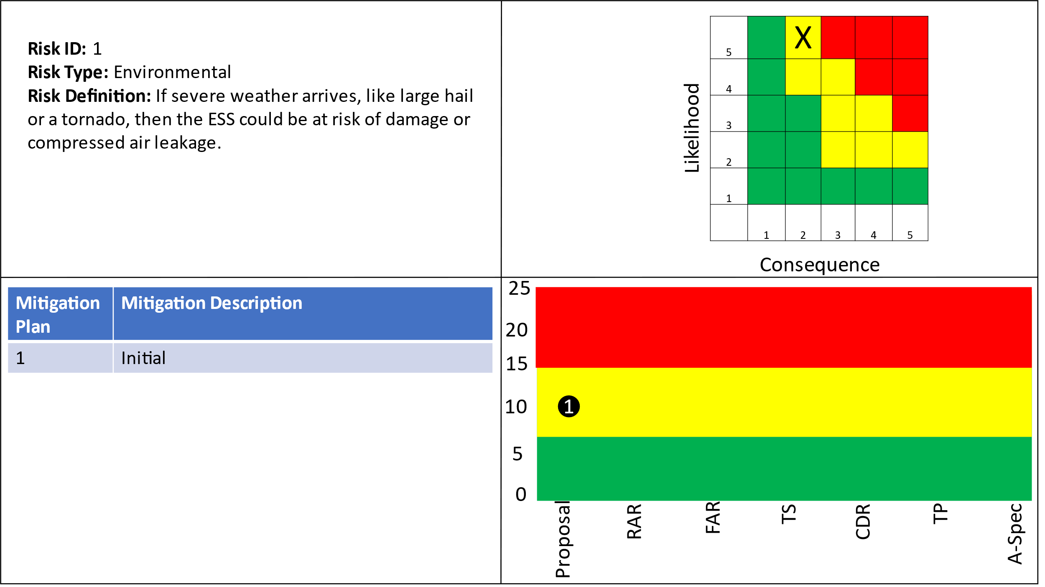

## 4.6.2 Risk 2:Earthquakes

Figure 7: Risk 2 Worksheet

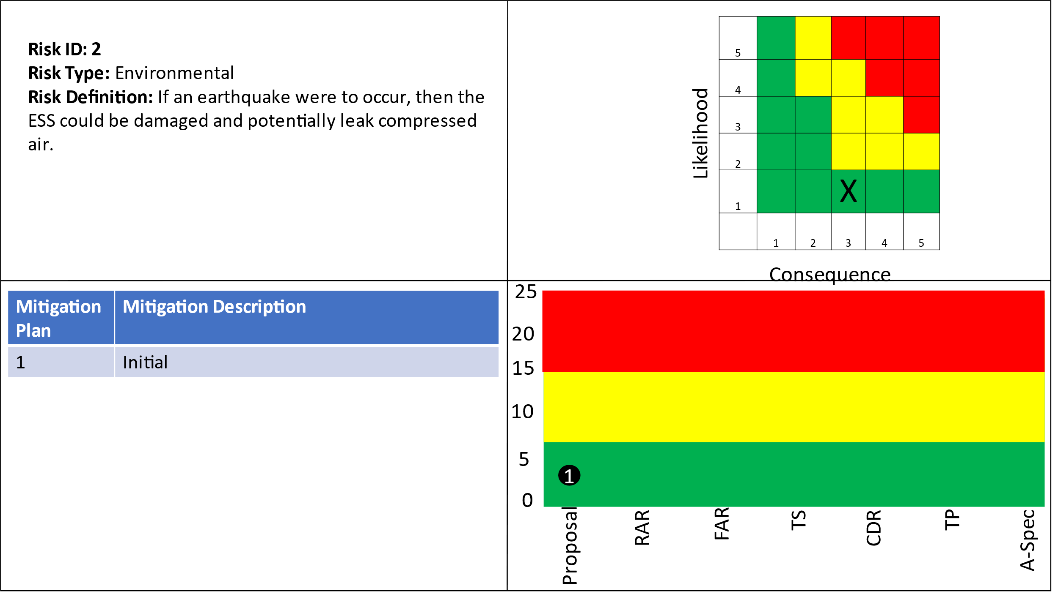

## 4.6.3 Risk 3:Residual Natural Gas

Figure 8: Risk 3 Worksheet

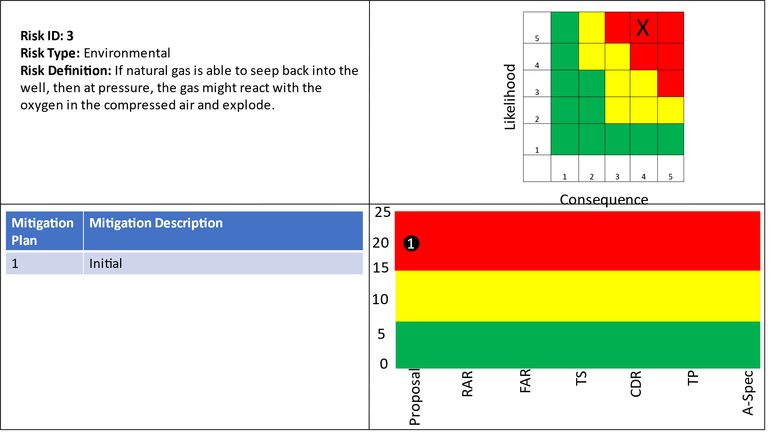

## 4.6.4 Risk 4:Cyber Security

Figure 9: Risk 4 Worksheet

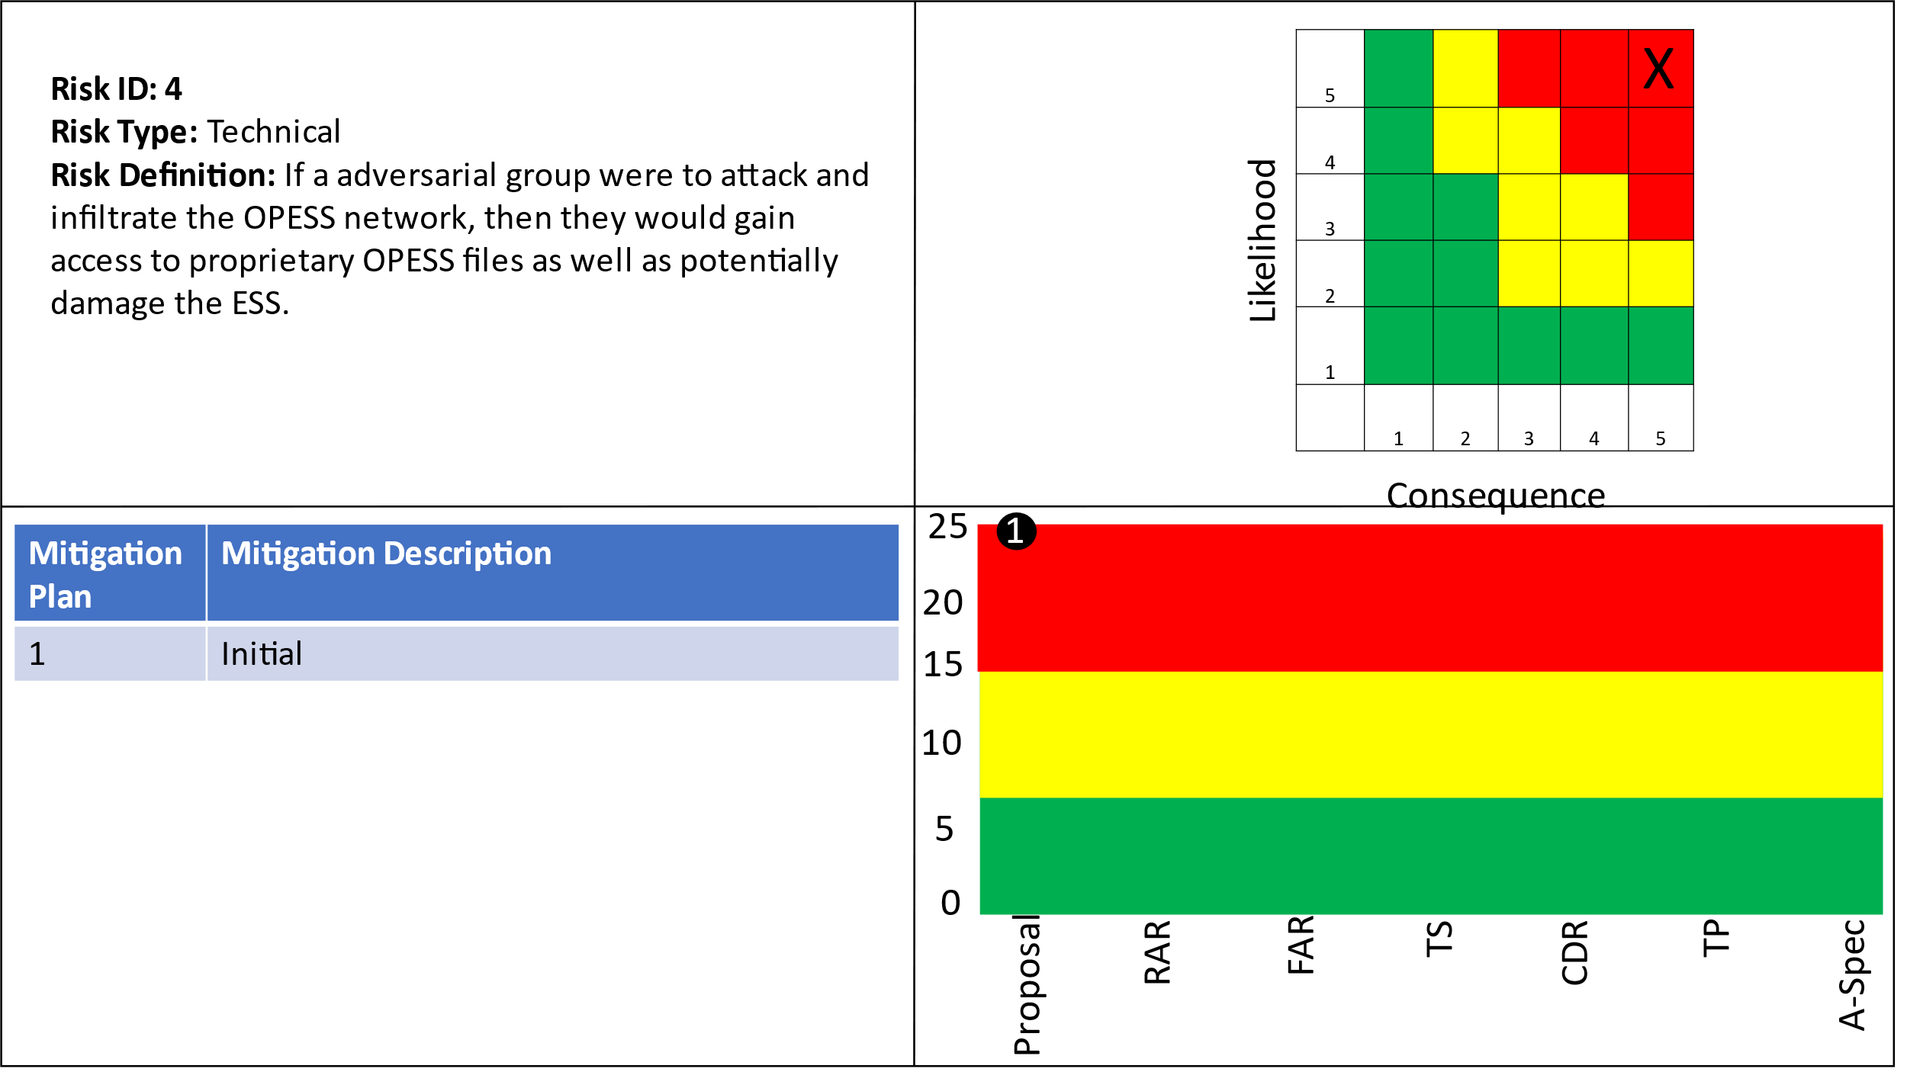

5 Systems Engineering Justification

## 5.1 Why systems Engineering

The electrical grid in Oklahoma is moving rather quickly towards the adoption of green, renewable energy. In order for this greener future to continue to power our homes safely and reliable, new energy storage solutions need to be established and implemented on a grid level. Unfortunately, understanding and integrating with the United States power grid is no easy thing to do. It is by far one of the most complicated and ever changings systems that is never given a second thought today. In order to integrate into the power grid, the OPESS will be required to take an system engineering approach in an effort to flush out it’s own design.

The use of the systems engineering V will allow us to models the system at a high level, break those models down into requirements, develop engineering builds, then test and integrate the resulting system in a way that will incrementally grow the capabilities of the OPESS system.

## 5.2 Three operational scenarios

In an effort to flush out the needs that will be required of the OPESS, three operational scenarios have been developed as a part of this proposal. While these scenarios do no account for every scenario that the OPESS might face over its operational life time, they will cover the three most common.

**Scenario 1:** It’s a nice spring day and the wind is blowing. Most of the wind farms across Oklahoma have been well maintained and are fully operational. This has led to an over production of energy across the state that will not be able to be used. Under normal circumstances, the operators of the wind farms will shut down turbines so that the flow of power across the grid is stabilized. With the OPESS up and running however, this is not the case. The wind farms are able to take full advantage of the natural wind present in the plain states, storing the extra energy they produce in the OPESS so that it might be retrieved at a later date.

**Scenario 2:** A high pressure system has moved in across the state and gotten itself stuck. The high pressure has helped to cap the local weather and is currently keeping the vast majority of the wind farms located across the state from being able to produce any real meaningful power. In this situation, the OPESS kicks on, releasing compressed air that has been stored now for months into it’s turbines and helping to generate the power that might have otherwise been lacking. By relying on the OPESS, the state is able to avoid ramping up it’s natural gas plants, keeping carbon emissions to a minimum.

**Scenario 3:** During a typical summer day, the wind is blowing but the high heat of the day is causing electrical demand to spike at the air conditioning systems of countless homes and businesses come on and run. This need for power though is not constant as AC units turn on and off based on their own local environment and not at the whims of the utility providers. As such, the OPESS system is having to supply a little extra power to make up for the increased demand. Unfortunately, since the need for power is not holding constant, the required output for the OPESS system might be at times below the minimum output the system is capable of. As such, the OPESS pumps are also turned on in other locations, allowing different ESS sites, to both generate the bare minimum of power, or greater when needed, while also pulling some of that excess power off the grid so as to help maintain stability. In this way the OPESS is able to help stabilize the power available on the grid at any given time.

Table 5: Scenario Summary

| Scenario Number | Summary |
| --- | --- |
| Scenario 1 | An overgeneration of power has led to a surplus of electricity on the grid. The OPESS store that power to keep the grid from being overloaded. |
| Scenario 2 | An under generation of power has led to a potential brownout situation. The OPESS will generate power using it’s stored reserves. |
| Scenario 3 | The OPESS system both generates and stores power on the grid at the same time. This smooths out the variates in the demand curve allowing for a better maintained grid. |

## 5.3 Measures of Effectiveness

**MOE 1 Energy Efficiency:** All energy storage solutions have some form of energy loss associated with them. The measure of that energy loss will be an important point when choosing design specifications and hardware decisions.

**MOE 2 Energy Storage Duration:** The OPESS system will need to be able to hold and store energy for a long time so as to help smooth over the production vs usage curve. The amount of time the OPESS can store energy will be of critical importance.

**MOE 3 Network Security:** The ESS and CaCS communicate to each other over the internet. The security of that connection will be a critical measure of the OPESS.

**MOE 4 Safety of ESS Subsystem:** The ESS will be exposed to the elements at all times. The design of the ESS will have to take this into account. The effectiveness of these solutions will be an important measure of the effectiveness of the ESS subsystem.

**MOE 5 Carbon Emissions**: The whole point of the OPESS is to help boost the effectiveness of green energy solutions in an effort to replace dirtier ones as they exist now. Making sure the use of natural gas wells does not also create a source of carbon emissions will be among its most important measures of success.

Table 6: MOE Summary

|  |  |
| --- | --- |
| MOE Number | Summary |
| MOE 1 | The energy efficiency of the OPESS must be high enough to be of worth to the market. |
| MOE 2 | The ESS must be able to store energy on the time span of months to years. |
| MOE 3 | The OPESS much adhere to proper cyber security standards. |
| MOE 4 | The ESS should be able to stand up to the elements. |
| MOE 5 | The OPESS must not produce carbon emissions. |

## 5.4 Measures of Performance

**MOP 1 Efficiency of Air Pump:** Some energy will be lost due to the efficiency of the air compressor. An efficiency of 80% will be desired in the ESS.

**MOP 2 Efficiency of the Generator:** Some energy will be lost due to the efficacy of the electrical generator. An efficiency of 60% will be needed for the ESS.

**MOP 3 Long Term Energy Storage Potential:** The ESS will need to be able to store energy for an extended period of time. The ESS will be required to store 75% or more of its stored energy for a year.

Table 7: MOP Summary

| MOP Number | Summary |
| --- | --- |
| MOP 1 | Efficiency of Air Pump |
| MOP 2 | Efficiency of the Generator |
| MOP 3 | Long Term Energy Storage Potential |

## 5.5 Tools and Techniques

**Tool 1 Risk Analysis:** The risk on the system will be continuously tracked and addressed at each stage of the OPESS development. In this way the risk can be monitored and risk reduction techniques can be employed.

**Tool 2 Functional Block Diagram:** Functional block diagrams will be produced. This way functions can be fully developed and tied together. This will help the developers look for any bugs or oversites in the system during development.

**Tool 3 Physical Block Diagram:** Physical block diagrams will be produced. This way no physical component will be missed or unknowingly isolated during the development process.

**Tool 4 N2 Diagram:** N2 (N Squared) diagrams will be produced to further look for missing logical connection on both the physical and functional models.

**5 Verification Cross Reference Matrix (VCRM):** A VCRM will be produced as a part of the test and integration phase. This will enable the developers to connect requirements to both a build schedule as well as a test plan. These builds, now being defined can be compared to the physical and functional block diagrams to look for potential gaps during integration.

Table 8: Tool Summary

| Tool Number | Summary |
| --- | --- |
| Tool 1 | Risk Analysis |
| Tool 2 | Functional Block Diagram |
| Tool 3 | Physical Block Diagram |
| Tool 4 | N2 Diagram |
| Tool 5 | VCRM |

# 6 References

NextEra Energy. (2020, November 17). *Oklahoma’s first battery energy storage system provides window into the future of renewable energy in region*. Retrieved from NextEra Energy: https://newsroom.nexteraenergy.com/Oklahomas-first-battery-energy-storage-system-provides-window-into-the-future-of-renewable-energy-in-region

NIST. (2018, Febuary 9). *NIST Cyber Security Framework*. Retrieved from Critical Infrastructure Resources: https://www.nist.gov/cyberframework/critical-infrastructure-resources

Popovich, N., & Plumer, B. (2020, 10 28). *How Does Your State Make Electricity?* Retrieved from The New York Times: https://www.nytimes.com/interactive/2020/10/28/climate/how-electricity-generation-changed-in-your-state-election.html

Quincy Compressor. (2020, September 4). *How Compressed Air Is Used for Renewable Energy*. Retrieved from Quincy Compressor: https://www.quincycompressor.com/compressed-air-energy-storage-renewable/

U.S. Energy Information Administration. (2022, May 19). *Oklahoma State Profile and Energy Estimates*. Retrieved from U.S. Energy Information Administration: https://www.eia.gov/state/analysis.php?sid=OK